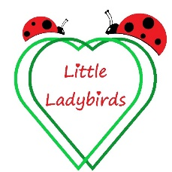
Illness and Infection Policy
Rationale
We are committed to providing an environment for children that helps prevent the spread of infection. This will entail children who are known to be infectious being kept away from our setting in order to maintain the health of others.
Procedure
If your child is slightly unwell due to a simple cold, teething etc. and can join in and enjoy the normal routines of the childminding day, please discuss this with us because they may still be able to attend. However happy your child is here when well, when poorly they will be much happier with their family, so if they are feeling really unwell, please keep them at home.
If your child develops a temperature they must stay home for at least 24 hours, once the temperature has subsided without the use of medication. This is the same for infectious illness such as chicken pox, please keep them at home until the infection passes. If your child has sickness or diarrhoea, they must not return until 48 hours after the last episode in order to prevent the spread of infection to others. Please feel free to consult us if you are not sure if your child’s symptoms mean that they need to stay at home.
If your child becomes unwell during the day, we will contact you and it may be necessary for you to collect them. We will keep your child as comfortable as possible until you arrive, but will not be able to isolate them from other children so a prompt collection is required.
Children with a notifiable disease must not attend until they have been cleared by their GP. If you are not sure if an illness is notifiable, please ask your GP or Health Visitor. We will inform you if any other child or adult has an infectious or notifiable disease. If a child who attends our setting has a notifiable disease, we are required to notify Ofsted as soon as reasonably practicable but always within 14 days. We will also contact Public Health England (PHE) and act on any advice given.
Written By:
Louisa Marley and Hannah Marley

NOVEMBER 2022

